Performance Matters
How to Upload Data to Performance Matters

STEP 1: Load your file(s) to your district’s FTP server with Performance Matters. (coreftp.performancematters.com)
-If you do not have the district’s User name and Password, please contact us. We will work with you to provide your district’s account information.

STEP 2: Login to PowerSchool Community (PowerSchool’s NEW support site).

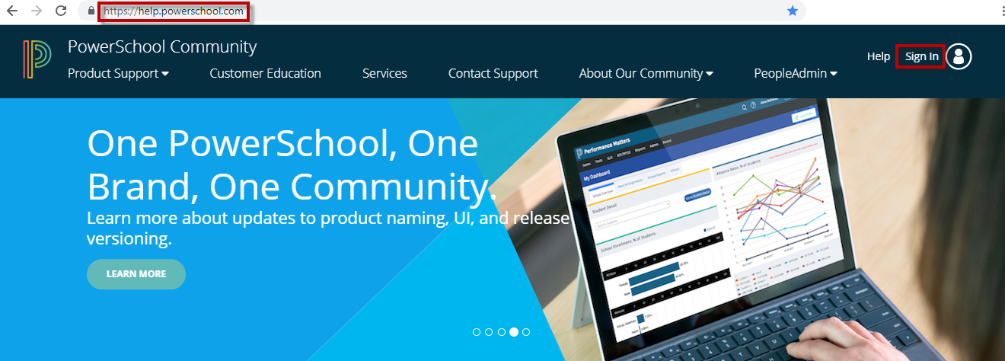
-Click Sign In.
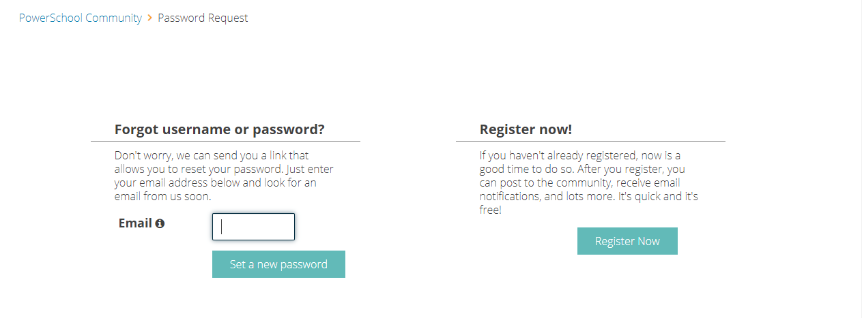
NOTE: You may need to register to create an account.
STEP 3: Create PowerSchool Community Case
-Once you are logged in, select Case Portal.
-Click New Case.

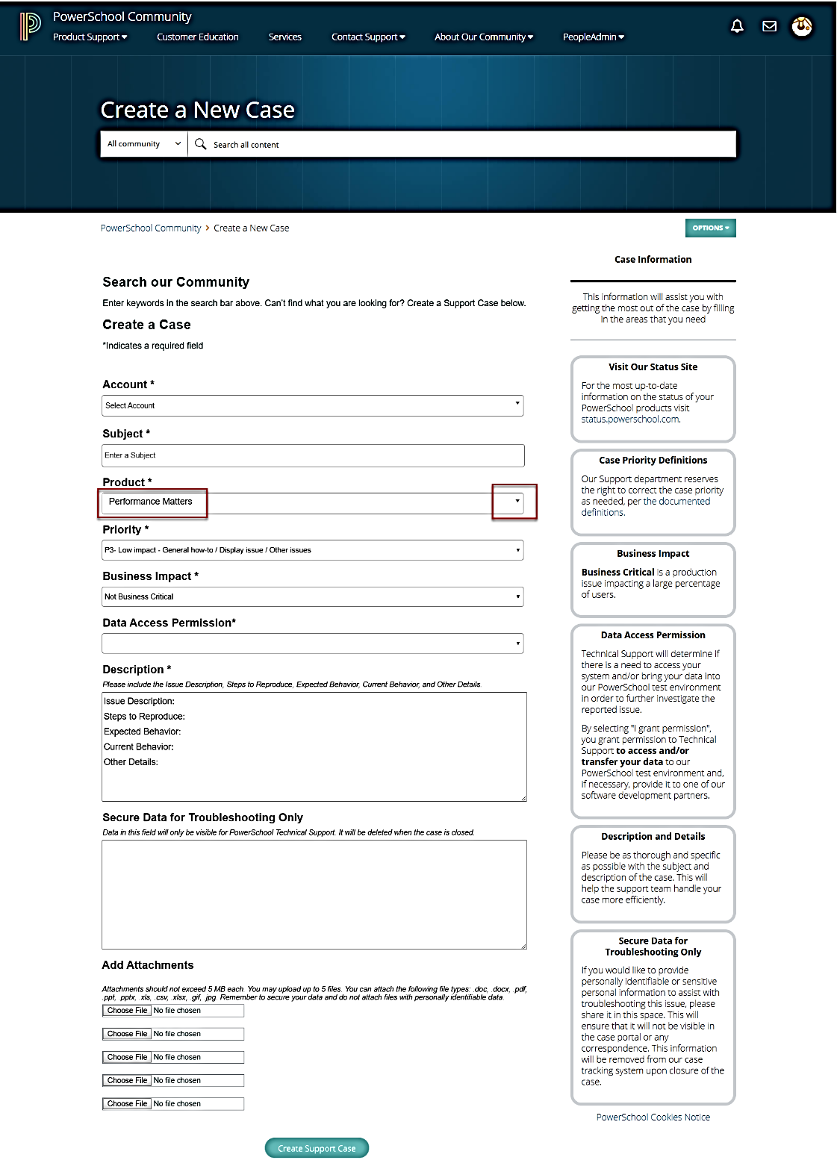
Click on the dropdown arrow and select Performance Matters from the Product menu.
Click on
Create Support Case
Fill in
Subject line
Description: Key information needed about the data to be submitted. (I.e.: 2018-2019 WWoods MWEA Spring)

